Store Sales Prediction

Wireframe Documentation

Store Sales Prediction

User Interface:

The user interface (UI) is the point at which human users interact with a computer, website or application. The goal of effective UI is to make the user's experience easy and intuitive, requiring minimum effort on the user's part to receive maximum desired outcome. The user can view the following web page once entering the web application.

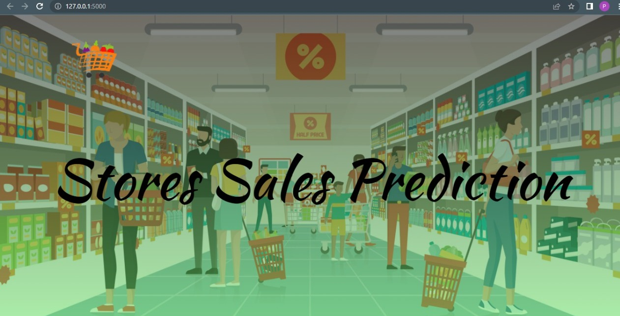

We have to input the desired values:

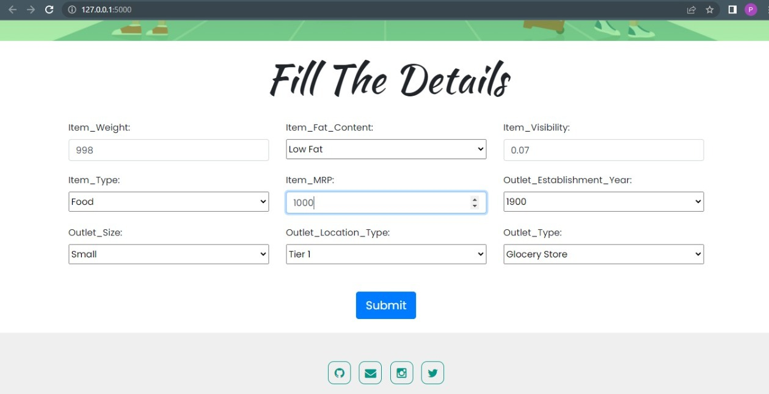

On clicking of the submit button, user will be directed to next page where he/she can see the predicted outcome.

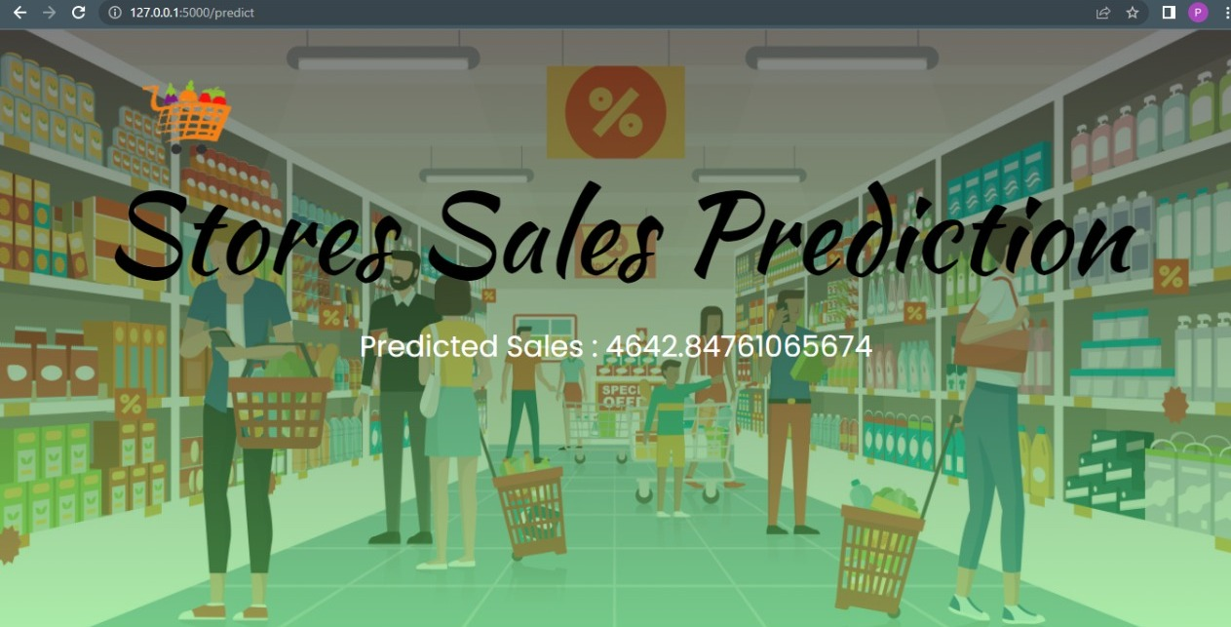

The predicted outcome can be used by the user in order to increase his sales.